Tank War Game Based on Q-Learning
Youtube: https://youtu.be/OkzuvAuusFI
Github: KI-cheng/QlearningTankWar: ML project

1 Introduction
This project uses the Q-Learning algorithm to design and implement a tank battle game. In this game, players will compete with AI-controlled enemy tanks. The enemy tanks are controlled by agents and make decisions based on the state of the environment. This project uses the following technology stack. Python is used as the main programming language. At the same time, PyTorch is an open-source deep learning framework that provides strong support for building and training DQN. We apply the Q-Learning algorithm based on PyTorch. Pygame is a library for game development that provides functions such as graphics, sound, and input processing. We use this library to implement game operation, dynamic updates, event detection, and UI rendering..

2 Game Design

2.1 Rules of the Game
In this game, we want the player to control a tank, with the goal of defeating all AI-controlled enemy tanks. Enemy tanks increase the difficulty of the game by dodging bullets. Each tank has three lives, and the game ends when the lives reach zero.
The state space of the game includes key information such as the position of the enemy tank, the position and direction of the bullets, etc. This state information will be used to train the deep learning model to guide the decision-making of the enemy tank. The action space of the enemy tank includes up, down, left, right, and stop. The agent will make judgments and perform actions based on the real-time state of the game..

2.2 Class Design of the Game
Game class responsible for managing the overall flow and state of the game. It initializes the game window and game objects, loads the AI ​​model, and updates the game state and handles collision detection during the game.
Trainer class used to train the AI ​​model. It generates random bullets, calculates rewards, trains the model, and saves the trained model.
Enemy class represents the enemy tank controlled by AI. It is responsible for the behavior and state update of the enemy tank, including getting the current state and selecting actions.
Player class represents the tank controlled by the player. It handles the player's input and controls the movement and shooting of the tank.
Tank class as the base class of Enemy and Player classes, it provides the basic functions and properties of the tank, such as movement, shooting, and collision detection.
Bullet class represents the bullet in the game. It handles the movement and collision detection of the bullet.

2.3 UI Design
The overall user interface follows a simple style. The game entry page displays the game name and game rules, as well as the description of the game buttons. The game uses pygame's UI rendering function to implement the design of black tanks and bullets. When the tank loses health, the color will change. The game interface is as follows. Bullets can hit walls and bounce off them during combat.
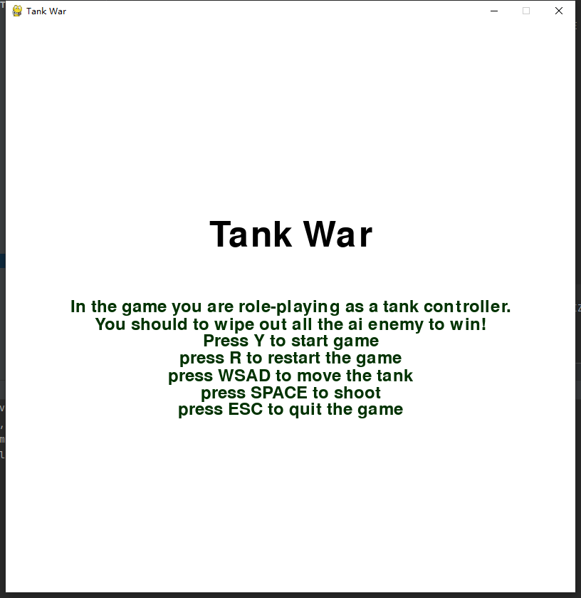
Fig 2.1 Tank War UI-1
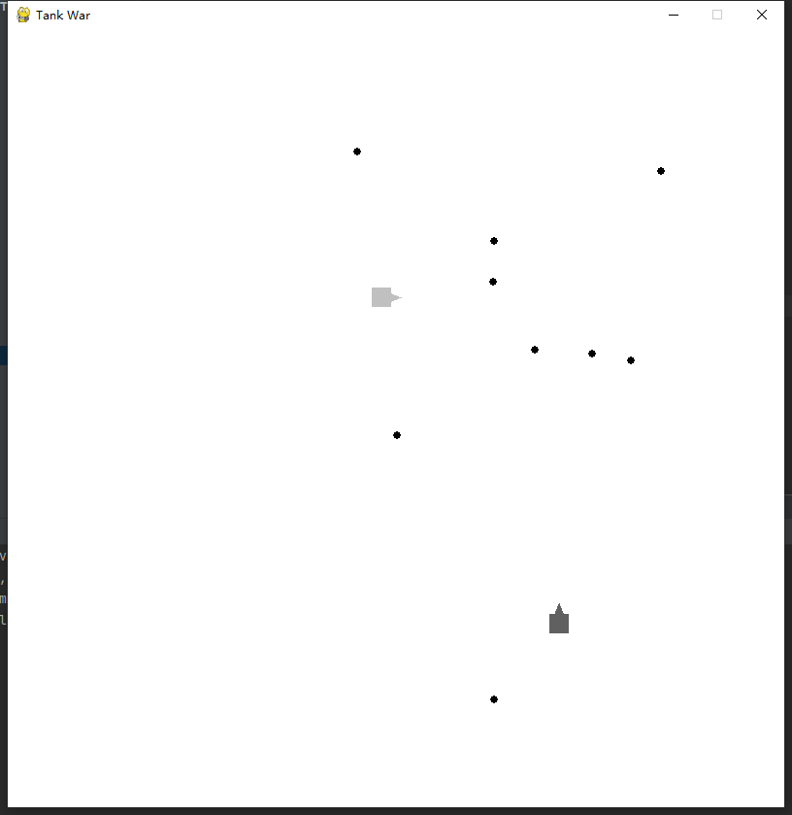
Fig 2.2 Fighting
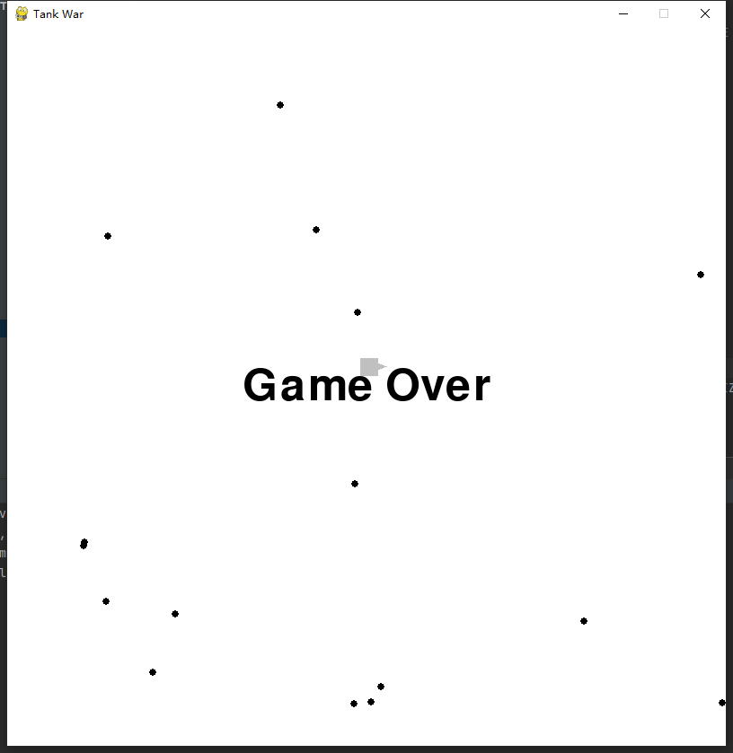
Fig 2.3 Game Over

3 Implement of Q-learning Algorithm
Q-Learning is a value-based reinforcement learning algorithm that selects the best action by learning a Q-value table. In our project, since my game is a continuous movement problem in a square space, the ordinary Q-learning algorithm can only use q-table to handle discrete action problems. So I used a deep Q-Learning network (DQN) to implement the Q-Learning algorithm. The network contains 4 fully connected layers with 256, 128, 64 and 5 neurons respectively. I use the ReLU activation function to introduce nonlinearity to help the network better learn the mapping relationship between complex states and actions.

We define a get_state function to obtain the current state of the game during training. The current state vector consists of the coordinates of the generated enemy tank, the coordinates of 10 random bullets, and the direction, forming a 42-dimensional vector. This state vector is used as the input of the neural network to predict the Q-value of each action.

During the training process, in order to ensure the training effect of the model, the enemy tank selects an action based on the current state. We use the ε-greedy strategy to balance exploration and exploitation. In the exploration phase, the model will randomly select an action. in the exploitation phase, the model will select the optimal action based on the current Q-value.

We set a series of training parameters to ensure that the model can learn effectively. The specific parameters are as follows: learning rate is 0.001, discount factor is 0.95, and batch size is 32. In addition, we set the number of training rounds to 300 rounds and store the experience accumulated during the game during training. Each experience includes the current state, the selected action, the reward obtained, the next state, and the flag of whether it is over. During the training process, we randomly extract a batch from the experience to update the weights of the network.

3 Challenges and Solutions
When I tried various reward models, I found that the complexity of the reward model was not positively correlated with the final learning effect. In order to ensure that the agent truly learned the ability to dodge bullets, we used a random generation method to initialize the bullets to avoid training solidification. How to find a reward model to allow the model to learn to dodge bullets has become an important issue and challenge. And how to set rewards and evaluation criteria to measure the performance of the intelligent agent is also an important issue. For example, if an enemy tank successfully avoids a bullet, it will receive a positive reward. If it is hit by a bullet, it will receive a negative reward. This reward mechanism helps guide the model to learn more effective strategies.
After several designs, I found an innovative way to measure the threat level of the bullet and determined the parameters required for the model to obtain the state. The key code is as follows.

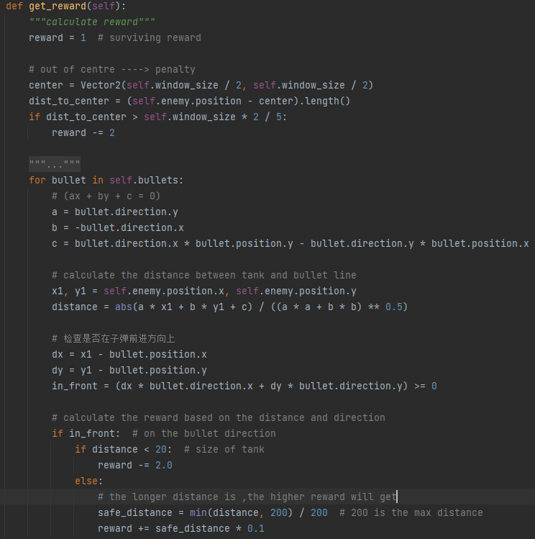
Fig 3.1 Reward function

We first designed a survival reward. As the survival time increases, the model gets more rewards. At the same time, in order to prevent the model from running to the edge of the map and not moving, we designed an edge penalty. Finally, we used the point-to-straight-line distance formula to let the agent avoid the trajectory of the bullet. If the distance from the position of the agent to the straight line formula of the bullet is less than its own size, a penalty will be imposed. In the end, it was proved that this design greatly improved the ability of the agent to avoid bullets.

4 Conclusion
During training, we observed that the performance of the model gradually improved as training progressed. The enemy tanks learned how to avoid bullets and survived longer and longer. We also noticed that the model achieved a good balance between exploration and exploitation, and was able to maintain a high survival rate while trying new strategies. During testing, we loaded the trained model and let the enemy tanks fight against the player-controlled tank. The results showed that the enemy tanks were able to effectively avoid the player's bullets and performed relatively stably in the game.
Through this project, we successfully implemented a tank battle game based on the Q-Learning algorithm. The enemy tanks in the game can continuously optimize their strategies through the learning algorithm and improve their survivability. This project not only demonstrates the application of the Q-Learning algorithm in games, but also provides us with an interesting experimental platform for exploring the potential and limitations of reinforcement learning algorithms. In actual tests, the trained model showed good performance, was able to take reasonable evasive actions when facing player attacks, and counterattacked at the right time. The overall battle process was smooth and had a certain degree of viewing.

5 Reference
[1] Wang, X. (2025). TankWar: Tank battle game [Computer software]. GitHub. https://github.com/wangxingyao/TankWar
[2] IronSpiderMan. (2020). TankWar: Classic tank battle game implemented with Python and Pygame [Computer software]. GitHub. https://github.com/IronSpiderMan/TankWar
[3] te. (2025). Tetris-deep-Q-learning-pytorch [Computer software]. GitCode. https://gitcode.com/gh_mirrors/te/Tetris-deep-Q-learning-pytorch

